The 17th International Postage Stamp Design Contest
- Award Winning Designs

□ Youth category – Sharing Hope
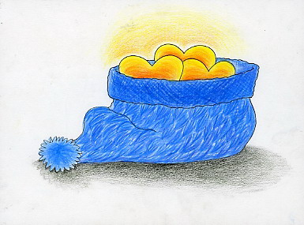 | 
Grand Prize  (to be issued as special stamp in 2012) | Award of Excellence
Yeong-ju JEONG  (17 years old, Dongil Girls' Computer Science & Design High School, Korea) | Mi-reu YOO  (17 years old, Daejin Design High School, Korea)

 | 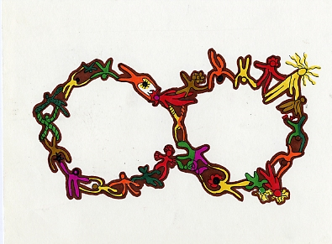
Honorable Mention | Honorable Mention
Wong Chung Ki  (9 years old, Simply Art,  Hong Kong, China) | Ji-yeon KIM  (18 years old, Jongno Polytechnic School, Korea)

 | 
Special Prize | Special Prize
Cheong Pok Man  (13 years old, Pui Ching Middle School, Macau, China) | Sa-hyeon MIN  (15 years old, Daegu Sangwon High School, Korea)

 | 
Special Prize | Special Prize
Seon-yeong PARK  (17 years old, Hanseong Girls' High School, Korea) | Geon-yeong LEE  (17 years old, Dongil Girls' Computer Science & Design High School, Korea)

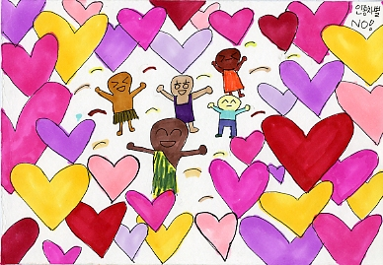 | 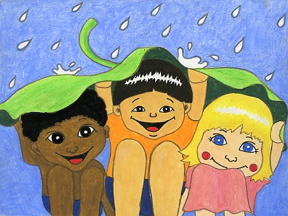
Special Prize | Special Prize
Jeong-yeon KIM  (16 years old, Daejin Design High School, Korea) | Han-sol MUN  (17 years old, Bangsan High School, Korea)

 | 
Special Prize | Special Prize
Eun-sol KIM  (17 years old, Dongil Girls' Computer Science & Design High School, Korea) | Eun-hye KIM  (15 years old, Daegu Jeil Girls' Commercial High School, Korea)

 | 
Special Prize | Special Prize
Cheong-un KIM  (15 years old, Hyeonhwa High School, Korea) | Seon-mi JANG  (18 years old, Bundang Information Industry High School, Korea)

□ General category – Sharing Hope
 | 
Grand Prize  (to be issued as special stamp in 2012) | Award of Excellence
Glen M. Isaac  (31 years old, Philippines) | So-yul PARK  (26 years old, Korea)

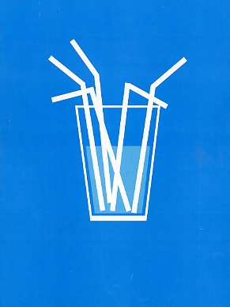 | 
Honorable Mention | Honorable Mention
Wong Chan  (21 years old, Macau, China) | Cho Zaw Aung  (25 years old, Myanmar)

 | 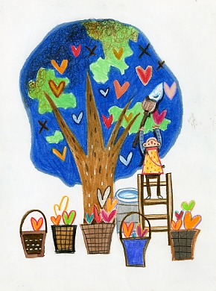
Special Prize | Special Prize
Eun-jeong KIM  (27 years old, Korea) | Yu-seong CHOI  (25 years old, Korea)

 | 
Special Prize | Special Prize
Seul-i LEE  (42 years old, Korea) | Su-jin KIM  (31 years old, Korea)


Special Prize
Ji-hee KIM
(30 years old, Korea)

o Award for the Guidance Teacher

Name of School/Institute | Name of Teacher | Remarks
Dongil Girls' Computer Science & Design High School (Korea) | Seon-yeong HUR
Jongno Polytechnic School (Korea) | Geon-hwa KIM
Youngsin Girls’ High School (Korea) | Bae-young KIM
Simply Art (Hong Kong, China) | Lee Chui Fan

