The 19th International Postage Stamp Design Contest
- Award Winning Designs

□ New Year Greetings – Youth Category

 | 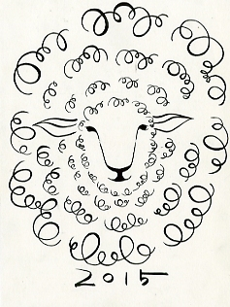
Grand Prize  (to be issued as special stamp in 2014) | Gold Prize  (to be issued as special stamp in 2014)
*-tae GOO  (Keonkuk High School, Korea) | *-jin YANG  (Seoul Design High School, Korea)


Silver Prize
Sarita Quimpo Chiu
(Berea Arts & Sciences High School,
the Philippines)

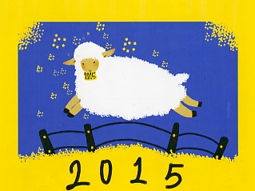 | 
Bronze Prize | Bronze Prize
*-gi CHO  (Seoul Design High School, Korea) | Wong Wai  (Guang Da Middle School,  Macau, China)

□ New Year Greetings – General Category

 | 
Grand Prize  (to be issued as special stamp in 2014) | Gold Prize  (to be issued as special stamp in 2014)
*-hee HONG  (Korea) | *-beom CHO  (Korea)


Silver Prize
*-jeong KWON
(Korea)

 | 
Bronze Prize | Bronze Prize
Jesus Ramos Tejada  (the Philippines) | Jamille Bianca Tan Aguilar  (the Philippines)

□ Stamp Collecting – Youth Category

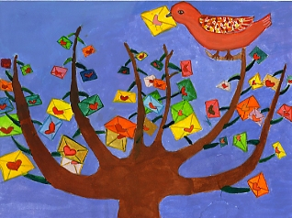 | 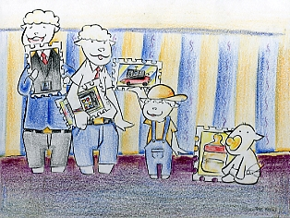
Grand Prize  (to be issued as special stamp in 2014) | Gold Prize  (to be issued as special stamp in 2014)
*-seo CHOI  (Chungryong Elementary School, Korea) | *-ryeol KIM  (Bundang Management High School, Korea)

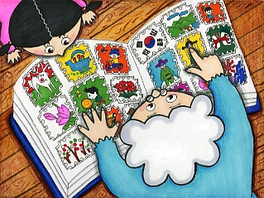
Silver Prize
*-ho KANG
(Pyeongnae High School, Korea)

 | 
Bronze Prize | Bronze Prize
*-yeon KIM  (Dongil Girls’ Computer Science & Design High School, Korea) | Sarita Quimpo Chiu  (Berea Arts & Sciences High School,  the Philippines)

□ Stamp Collecting – General Category

 | 
Grand Prize  (to be issued as special stamp in 2014) | Gold Prize  (to be issued as special stamp in 2014)
*-ji CHO (Korea) | *-young PARK  (Korea)


Silver Prize
Glen M. Isaac
(the Philippines)

 | 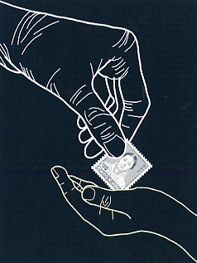
Bronze Prize | Bronze Prize
*-young YOO (Korea) | *-bae LEE (Korea)

o Award for the Guidance Teacher

Name of School/Institute | Name of Teacher | Remarks
Seoul Design High School (Korea) | *-gi PARK
Bundang Management High School (Korea) | *-hee PARK
Dongil Girls’ Computer Science & Design High School (Korea) | *-seok HEO
Yeoju First Middle School (Korea) | *-su CHUNG

